Cincinnati
1Children'sN
changing the outcome together

2/21/2018

Dear Parent or Guardian,

We are very pleased to let you know that our partnership of Norwood City Schools and the Center for Better Health and Nutrition is offering cardiovascular risk screening at the Norwood Middle School. If you and your child give permission to take part in this screening, your child will be screened for high cholesterol and triglycerides, pre-diabetes, high blood pressure, body fat percentage and be checked for a good weight for height (body mass index). All these conditions can lead to an increased risk of heart
disease and can be treated. Since these conditions are common, all 7th and 8th graders are being invited
to participate. If your child participates, a small blood sample will be taken using a finger prick. We will send you a report of the screening results and make suggestions if any of the values are of concern to your child's health. Please sign the enclosed permission form, complete the parent/guardian survey and return them to the school nurse or advisory teacher.

We firmly believe that if we find any of these problems early, we can link you with treatment services and improve your child's health. We will be studying the results of this project and your child's participation could add to our knowledge of these conditions which increase the risk of heart problems. This screening is completely voluntary and you do not have to participate if you and your child do not want to. If you have any questions, you can call Kathy Strasser, RN at 513-924-2882. Thank you so
much.

Sincerely,

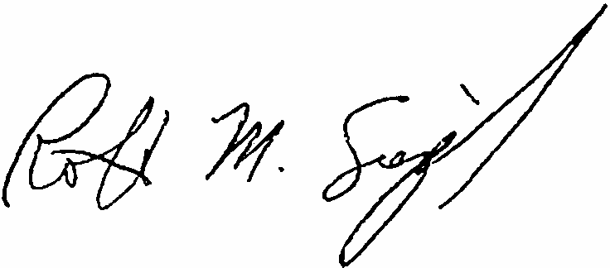

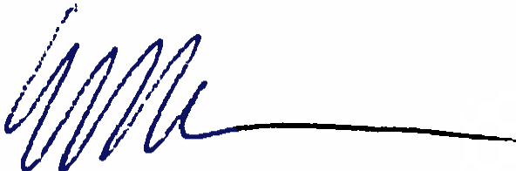Robert Siegel, MD Medical Director
The Center for Better Health and Nutrition
Elaine Urbina, MD Director
Preventive Cardiology

V3.0 09Feb2018

IRB #: 2017-7416

Cincinnati
Children's...
changing the outcome together
Approved:
2/18/2018
Do Not Use After:
12/21/2018

AGREEMENT TO PARTICIPATE IN CARDIOVASCULAR RISK SCREENING

Cincinnati Children' s Hospital Medical Center (CCHMC) is offering a cardiovascular risk screening the 71h and gth grade classes at Norwood Middle. The purpose of the event is to offer a comprehensive screening to identify children with high cholesterol or triglycerides, high blood pressure, high body fat and diabetes and to educate the parents of children who are identified with any of these health risks. We are asking for your permission for your child to participate in this event at school by signing this form and returning it to school prior to the event. Also included is a short survey for the parent/guardian to fill out. This screening and survey is voluntary. If you choose for your child not to participate in this event, that is okay. Your child will not lose any rights or benefits to which he/she is otherwise entitled. The data collected as part of this screening program will be reviewed by medical personnel participating in the event. This data may be used as part of a research study on heart health in adolescents at CCHMC. By agreeing to participate in this program, you understand and provide permission that the data collected can be included in a research study. The screening will occur at school during a couple hours of the school day. Your child will be in the study for about 15-30 minutes. The screening
will include:

• Body Mass Index
• Percent body fat
• Blood pressure, weight, and height
• Finger stick for blood to obtain the following levels o Cholesterol
o HDL
o Triglycerides
o HgA1C

Your child might have some slight discomfort from the pressure of the blood pressure cuff. Your child may also
experience slight discomfort or distress with the finder stick. This risks associated with this procedure are minimal. Trained staff will perform the finger stick and will make sure the area is cleaned very well in order to minimize the risk of infection. Study personnel will provide you and your child with a summary of the results of the screening. Any additional testing recommended by your child's physician will not be provided by the study and any costs of additional testing will be your responsibility. If you do not feel comfortable filling out the short survey, you are under no obligation to do so.

CCHMC will protect your child's data and we will not use any identifying information of your child in any publications or presentations that result from the data. Only individuals directly working on this research will have access to your child' s data at CCHMC and the data will be kept in password protected electronic files and/or locked storage cabinets that may be housed at the office of CCHMC. No information or data from this study will be maintained by the school.

As participant or parent/legal guardian of the participant, I acknowledge that I have read the above agreement to participate and understand its contents. Any questions have been answered to my satisfaction. I agree to allow my child to participate in this cardiovascular risk screening, and, I consent to the release of information obtained in connection with
the screening as described above. I understand that CCHMC will not disclose my child' s identity to any third party without consent. I understand that I may withdraw my child from the screening at any time. I further agree to hold CCHMC, all physicians, technicians, nurses, volunteers, and all other persons, entities, individuals, and organizations as harmless and waive all subrogation rights against CCHMC.
Your participation is voluntary and you may withdraw your participation in this study at any time.

If your child has a pacemaker or orthopedic hardware (metal pins or rods) or is pregnant, they will not be able to have their body fat percentage measured.

(initial) YES, my child does have a pacemaker/orthopedic hardware or is pregnant and should not have their body fat measured.

(initial) NO, my child does not have a pacemaker/orthopedic hardware and should have their body fat measured.

Your child will receive a $10 Kroger gift card for returning this permission form and completing the screening. V3. 0_14Feb2018 Page 1 of 2

IRB #: 2017-7416

Cincinnati
Children'sN
changing the outcome together
',

Approved:
2/18/2018
Do Not Use After:
12/21/2018

HIPAA AUTHORIZATION FOR USE/DISCLOSURE OF PROTECTED HEALTH INFORMATION FOR A RESEARCH STUDY.: We understand that information about you and your health is personal and we are committed to protecting the privacy of that information. Because of our commitment to protect your privacy, we must obtain your written authorization (permission) before we may use or disclose (release) your "protected health information" (sometimes referred to as "PHI") related to this study. This form provides that authorization and helps us make sure that you are properly informed of how this information will be used or disclosed.

USE AND DISCLOSURE COVERED BY THIS AUTHORIZATION. If you sign this document, you give permission to Cincinnati Children's Hospital Medical Center ("Cincinnati Children's") to use or disclose your medical and research information for the purpose of this study. Your PHI that will be used and disclosed in connection with this study consists
of your screening and survey results.

WHO WILL DISCLOSE, RECEIVE AND/OR USE THE INFORMATION? This form authorizes the following to disclose, use and receive your PHI: study staff working on this study and members of the Cincinnati Children's Institutional Review Board and staff of the Office of Research Compliance and Regulatory Affairs.
By signing this document, you are authorizing Cincinnati Children's to use and/or disclose your PHI for this study. Those persons who receive your information may not be required by Federal privacy laws (such as the Health
Insurance Portability and Accountability Act, also known as "HIPAA") to protect it and may share the information with
others without your permission, if permitted by laws governing them.
The information entered into the database will be maintained even after participation has ended and will only be removed upon your written request. You may revoke (choose to withdraw) this authorization at any time after you have signed it by providing Dr. Siegel (the Principal Investigator) with a written statement that you wish to revoke it. Your revocation will be effective immediately and your PHI can no longer be used or disclosed for this study by Cincinnati Children's and the other persons or organizations that are identified above, except to the extent that Cincinnati Children's and/or the other persons or organizations identified above have already acted in reliance on the Authorization. In addition, the information may continue to be used and/or disclosed to preserve the integrity of the study.
Unless you notify us in writing of your decision to withdraw this authorization to use and disclose your PHI, as the
study involves the creation or maintenance of a research database repository, this authorization will not expire.
For further information about your rights, please see the Cincinnati Children's Notice of Privacy Practices on our website at https://www.cincinnatichildrens.org/site/privacy.

SIGNATURES: I have read the information given above. I am aware that, like in any research, the investigators cannot always predict what may happen or possibly go wrong. I have been given sufficient time to consider if my child should participate in this study. I hereby give my permission for my child to take part in this study as a research study subject.

For questions regarding the screening event or the data collected, please contact: Dr. Robert Siegel from Cincinnati
Children's Hospital Medical Center at (513) 636-9420.

Name of Participant: Signature of Participant: Date: _ Signature of Parent/Legal Guardian (if participant is younger than 18) : Date: _ Relationship to Participant: _

V3.0_14Feb2018 Page 2 of 2

